**PROJECT SYNOPSIS**

**Data Driven Art Generator &**

**Storytelling Visualization**

**BACHELOR OF COMPUTER APPLICATIONS (HONOURS)**

(Data Science)

SUBMITTED BY:

Yuvraj Singh Kushwah (2023BCAH062)

Subhro Pal (2023BCAH056)



**JAGRAN SCHOOL OF COMPUTER APPLICATIONS (JSCA)**

**FACULTY OF SCIENCE AND TECHNOLOGY (FAST)**

**JAGRAN LAKECITY UNIVERSITY, BHOPAL (M.P.)**

**INDEX**

|  |  |  |
| --- | --- | --- |
| **S. No.** | **Content Title** | **Page No.** |
| 1. | Title Page | 1 |
| 2. | Notations | 2 |
| 3. | Abstract | 3 |
| 4. | Motivation | 4 |
| 5. | Literature Review | 6 |
| 6. | Analysis | 8 |
| 7. | Objectives | 9 |
| 8. | Software/Hardware Requirements | 10 |
| 9. | Methodology | 12 |
| 10. | Analysis Models (DFDs) | 14 |
| 11. | Conclusion | 17 |
| 11. | References | 18 |

**NOTATIONS/ NOMECLAUTRE**

|  |  |
| --- | --- |
| **Term** | **Description** |
| API | Application Programming Interface (e.g., Groq API, Stability AI API, GNews API) |
| LLM | Large Language Model (e.g., LLaMA 3.3-70B for narrative generation) |
| DFD | Data Flow Diagram (visualizes system processes and data interactions) |
| UI/UX | User Interface / User Experience (CONTRA’s frontend design principles) |
| SD 3.5 | Stable Diffusion 3.5 (AI model for generating stylized imagery) |
| CDN | Content Delivery Network (optimizes global image loading speeds) |
| TF-IDF | Term Frequency-Inverse Document Frequency (text analysis for context mining) |
| CRUD | Create, Read, Update, Delete (data management operations if implemented) |
| Caching | Smart storage of frequent API responses to reduce latency and costs |
| Plotly | Library for creating interactive data visualizations (e.g., timelines, graphs) |

**ABSTRACT**

CONTRA is an advanced AI-powered platform that transforms basic user ideas into richly layered multimedia narratives, blending data-driven art with dynamic storytelling. By merging cutting-edge artificial intelligence with creative design, the system crafts immersive experiences that weave together diverse data sources into unified visual and textual presentations. Developed using Python's Flask framework, the platform intelligently integrates external APIs to produce outputs that harmonize AI-generated text, custom visuals, and interactive elements.

When users submit a topic via CONTRA’s streamlined interface, the platform activates a sophisticated analysis pipeline. It begins by aggregating foundational data: fetching overviews from Wikipedia, organizing categorical insights through DBpedia’s semantic queries, and scanning real-time news via GNews. This curated information fuels three key creative engines:

(1) **Story Crafting** – Groq’s LLaMA 3.3-70B API transforms data into engaging narratives, balancing succinct summaries with in-depth explanations;

(2) **Visual Design** – Stability AI’s Stable Diffusion 3.5 generates stylized imagery tailored to user-defined moods and aesthetics;

(3) **Data Exploration** – Plotly-powered interactive diagrams (timelines, concept webs, and relational graphs) reveal hidden patterns within the subject matter.

Architecturally, CONTRA operates through four interconnected layers: API gateways for external services, processing modules for content generation, data models for structured organization, and utility systems for performance optimization. A smart caching system minimizes redundant API calls while accelerating response times. The frontend delivers a polished experience with tabbed navigation, letting users fluidly switch between textual analyses, artistic interpretations, and data-driven insights.

This project pioneers a hybrid approach to automated content creation, fusing factual rigor with artistic expression. By strategically combining multiple AI systems, CONTRA demonstrates how technology can make complex subjects accessible and engaging through a blend of formats—educating audiences while captivating them aesthetically.

**Motivation**  
The digital age presents a striking contradiction: while information is more abundant than ever, turning raw data into meaningful understanding remains needlessly challenging. Conventional platforms compartmentalize knowledge—text-heavy articles miss visual storytelling, image galleries lack context, and charts sit disconnected from narrative explanations. This fragmentation forces users to piece together insights like a puzzle, slowing learning and diluting engagement. CONTRA was born from the vision to bridge these gaps, harnessing AI’s potential to unify facts, visuals, and stories into one immersive experience.

Four core principles guided our work:

1. **Supercharging Understanding with Mixed Media**  
   Cognitive studies confirm that layered learning—combining text, visuals, and interactive elements—boosts comprehension and memory. CONTRA applies this science by auto-generating aligned content across formats, letting users explore topics through their preferred “lens” while reinforcing key ideas.
2. **AI for Everyone, Not Just Experts**  
   Cutting-edge creative tools like LLMs and image generators often demand technical skill to wield effectively. CONTRA flips this dynamic, integrating these technologies into a single intuitive space where casual users can harness professional-grade AI without coding or complex workflows.
3. **Creativity Anchored in Reality**  
   Many generative AI systems produce imaginative but ungrounded outputs. CONTRA counters this by rooting its work in trusted sources: Wikipedia’s encyclopedic base, DBpedia’s structured knowledge, and GNews’ real-world updates ensure outputs stay factual even as they innovate.
4. **Where Knowledge Meets Imagination**  
   Why choose between learning and inspiration? CONTRA merges the two, transforming dry data into visually striking timelines, concept maps, and stylized artwork. This fusion invites users to not just consume information but *experience* it—sparking curiosity through artistry.

By tackling these challenges, CONTRA reimagines how we interact with information, turning brief prompts into multidimensional journeys that adapt to individual learning styles. It’s more than a tool—it’s an invitation to explore complex subjects with both clarity and wonder.

**Literature Review**

The intersection of AI-driven storytelling and cultural visualization has sparked diverse innovations across generative AI, narrative design, and human-centered systems. Below, we analyze pivotal approaches and their tradeoffs to contextualize CONTRA’s contributions:

|  |  |  |  |
| --- | --- | --- | --- |
| **Study** | **Approach** | **Strengths** | **Limitations** |
| Ferracani et al. [1] | Mobile-first cultural stories (GPT-4 + images) | Delivers dynamic mobile stories with rich visuals | Resource-heavy; risks narrative inaccuracies |
| Liem et al. [2] | InTaVia’s curation-focused heritage platform | Powerful museum-grade curation tools | Minimal automation; expert-dependent |
| Xu et al. [3] | ArtifactShow’s AI-augmented narratives | Immersive, imagination-sparking experiences | Fact-checking challenges; bias risks |
| Segel & Heer [4] | Foundational narrative visualization principles | Timeless “playbook” for structuring data stories | Manual effort; no generative features |
| Hullman & Diakopoulos [5] | Rhetorical analysis of visualization impact | Reveals storytelling psychology in data design | Theory-focused; no automation tools |
| Chen et al. [6] | Educational visual storytelling frameworks | Makes complex topics click for learners | Niche focus; less adaptable culturally |
| Card & Mackinlay [7] | Interactive exploratory visualization systems | Lets users play “data detective” freely | Prioritizes exploration over storytelling |

This landscape reveals a critical gap: most systems either lean on labor-intensive human expertise *or* prioritize generative flair over factual reliability. CONTRA positions itself at the intersection—automating data synthesis and narrative generation while grounding outputs in verified sources. Unlike predecessors, it harmonizes three pillars:

1. **AI-Powered Automation**: Reduces manual effort via integrated LLMs and diffusion models.
2. **Factual Anchoring**: Balances creativity with Wikipedia/DBpedia’s structured knowledge.
3. **Multimodal Exploration**: Merges text, visuals, and interactive charts into a single workflow.

By bridging generative innovation with scholarly rigor, CONTRA addresses the “automation vs. accuracy” divide observed in earlier systems.

**Analysis**

* **Rigid Template Systems**: Conventional rule-based visualization tools use fixed formats, struggling to adapt to varied cultural contexts or shifting user preferences. This “one-size-fits-all” approach hampers scalability and cross-domain use.
* **Flat Data Storytelling**: While traditional charts and dashboards clarify data, they lack emotional resonance and personalization. Audiences disengage when information feels impersonal or fails to “connect the dots” narratively.
* **AI’s Double-Edged Sword**: Models like GPT-4 excel at crafting vivid, tailored stories with images, but their hunger for computational power, curated data, and bias checks raises practical and ethical hurdles.
* **Expert-Dependent Hybrids**: Platforms like InTaVia blend human curation with AI assistance, ensuring cultural accuracy but sacrificing speed and scalability to manual oversight.
* **Multimedia Complexity**: Systems merging text, visuals, and interactivity captivate audiences but demand intricate engineering to harmonize formats without lag or disjointedness.

**CONTRA’s Solution**:  
Our system strikes a middle path, fusing AI’s generative power with structured visualization best practices. By automating narrative creation while anchoring outputs in verified data, CONTRA transforms raw cultural datasets into interactive stories *without* requiring supercomputers or coding skills. Key innovations include:

* **Smart Resource Use**: Optimized workflows run smoothly on standard hardware.
* **User-First Design**: Intuitive controls let educators and curators craft experiences, not troubleshoot tech.
* **Adaptive Storytelling**: Content evolves with user interactions, replacing static slides with living explorations.

This framework bridges AI innovation and human needs, offering museums, schools, and heritage groups a scalable toolkit to turn archives into engaging journeys. Beyond preserving culture, CONTRA democratizes sophisticated storytelling—proving advanced tech can empower, not exclude.

.**Objectives**

The CONTRA project was conceived to address the fragmentation in digital information consumption by creating a system that unifies multiple content modalities into a cohesive experience. By leveraging recent advances in AI technology, the platform aims to transform how users interact with and absorb information, moving beyond traditional single-format presentations to a richer, more engaging approach. The following key objectives guided the development process:

**Primary Objectives**

1. **Create a Unified Multimedia Content Generation System**: Develop an integrated platform that combines text narratives, AI-generated imagery, and data visualizations from a single user input.
2. **Automate Contextual Research**: Implement a system that enriches topics with relevant information from authoritative sources without requiring manual research.
3. **Leverage State-of-the-Art AI Models**: Utilize LLaMA 3.3 for text generation and Stable Diffusion 3.5 for image creation to produce high-quality content.
4. **Present Information Through Multiple Cognitive Channels**: Address diverse learning preferences through complementary modalities of textual explanations, visual imagery, and data visualizations.

**Technical Objectives**

1. **Develop a Modular, Extensible Architecture**: Create a system with separated functional components for future enhancements.
2. **Implement Robust API Integrations**: Build reliable connections to external services with appropriate error handling and fallback mechanisms.
3. **Design an Intelligent Caching System**: Optimize performance and reduce costs by avoiding redundant API calls.
4. **Ensure Cross-Format Content Coherence**: Maintain thematic consistency across different content formats.
5. **Provide an Accessible User Interface**: Design a clean, responsive front-end for users of varying technical abilities.

**Software/Hardware Required for Proposed Work**

To bring CONTRA to life, we’ve carefully chosen tools and resources that balance power with accessibility. Here’s what powers the system:

**Software Essentials**

* **Backend Brainpower**:
  + **Python 3.8+**: The backbone for scripting logic and data magic.
  + **Flask**: Lightweight web framework to handle user requests and glue everything together.
  + **Git**: Time-travel for code—track changes and collaborate seamlessly.
* **AI & Data Partnerships**:
  + **Groq API**: The storyteller (LLaMA 3.3-70B) crafting narratives on demand.
  + **Stability AI**: Digital artist (Stable Diffusion 3.5) painting your ideas into images.
  + **Wikipedia/DBpedia**: Fact-checkers fetching verified intel.
  + **GNews**: News hound sniffing out fresh topic angles.
* **Coding Toolbox**:
  + **Requests**: Handshake-maker for API chats.
  + **Plotly/Pillow**: Chart sculptor & image whisperer.
  + **Flask-CORS**: Peacekeeper for cross-website harmony.
* **Frontend Flair**:
  + **HTML5/CSS3**: Skeleton and style for the interface.
  + **JavaScript**: Puppeteer making buttons dance and charts react.
  + **D3.js/Plotly.js**: Architects of dynamic, eye-popping visuals.

**Hardware Needs**

* **For Deployment**:
  + **Brain (CPU)**: 4-core processor (8+ ideal for live use).
  + **Memory (RAM)**: 8GB base (16GB+ for busy sites).
  + **Storage**: 20GB SSD starter pack (grows with your cache).
  + **Internet**: Steady 10Mbps+ pipeline—no buffering tantrums.
* **For Developers**:
  + A decent laptop (quad-core, 8GB RAM) does the trick.
  + No fancy GPU needed—cloud APIs handle heavy lifting.

**Behind-the-Scenes Logistics**

* **Keys to the Kingdom**:
  + Paid subscriptions for Groq (story tokens) & Stability AI (art credits).
  + Free-tier GNews access (upgrade if news-hungry).
* **Traffic Cop Rules**:
  + Mind API speed limits (Groq/Stability tier-based, Wikipedia fair-use).

**Growing Pains? Scale Smart**  
For crowds flocking to CONTRA:

* **Speed Boost**: Add Redis/Memcached to cache like a pro.
* **Traffic Director**: Load balancer to juggle user waves.
* **Global Reach**: CDN to serve images faster worldwide.
* **Memory Bank**: PostgreSQL/MongoDB if saving stories long-term.

This setup balances cost and capability, letting CONTRA adapt from small experiments to full-blown exhibitions.

**Methodology**

CONTRA transforms basic prompts into multimedia journeys through a carefully orchestrated five-act process, blending AI creativity with engineering precision. Here’s how the magic happens:

**1. Fact-Finding Mission**

* **Topic Dissection**: First, CONTRA dissects the user’s query like a detective, mapping out what to investigate.
* **Data Safari**: It then scouts three key territories simultaneously:
  + *Wikipedia* → Encyclopedic foundations
  + *DBpedia* → Structured relationships (think “Who’s related to what?”)
  + *GNews* → Fresh real-world connections
* **Data Harmony**: Raw intel gets polished into a universal format—imagine translators converting dialects into one lingua franca.
* **Context Mining**: The system spots key players, timelines, and hidden connections, like a historian piecing together clues.

**2. Story Forging**

* **Smart Prompt Craft**: Armed with research, CONTRA whispers context-rich prompts to its AI wordsmith (LLaMA 3.3-70B), ensuring it “gets” the big picture.
* **Narrative Alchemy**: Groq’s API turns data into gold—balanced explanations that mix bullet-point clarity with engaging prose.
* **Story Surgery**: Output gets trimmed and polished, removing jargon tangles and sharpening focus.

**3. Visual Symphony**

* **Mood Board Creation**: The system crafts image prompts blending facts with user vibes (“Baroque meets cyberpunk for WWII analysis?”).
* **AI Art Studio**: Stability AI’s brush (Stable Diffusion 3.5) paints these visions into reality, adjusting strokes for requested styles.
* **Gallery Prep**: Images get web-ready makeovers—compressed without losing sparkle—then filed in CONTRA’s digital archive.

**4. Data Theater**

* **Pattern Spotlight**: The system hunts for timelines, categories, and hidden links worth visualizing.
* **Chart Casting**: It picks the perfect visualization role for each data type: timelines for history, webs for relationships, pie charts for breakdowns.
* **Plotly Choreography**: Interactive charts spring to life with color-coded clarity, ready to dance with user clicks.

**5. Grand Finale**

* **Multimedia Orchestra**: Text, images, and charts sync like instruments in a symphony—themes aligned, pacing perfect.
* **Stage Design**: A clean tabbed interface lets users curate their experience, flipping between “Story,” “Art,” and “Data” acts.
* **Behind-the-Scenes Crew**:
  + *Cache Librarians*: Store frequent requests to slash costs and speed encores.
  + *Safety Nets*: Gracefully handles API hiccups—if the news feed stumbles, the show goes on with cached data.

This assembly-line approach lets CONTRA spin simple queries into rich tapestries, ready to scale from classroom tools to museum installations.

**Analysis Models**

**Data Flow Diagram (DFD)**

**Level 0 DFD (Context Diagram)**

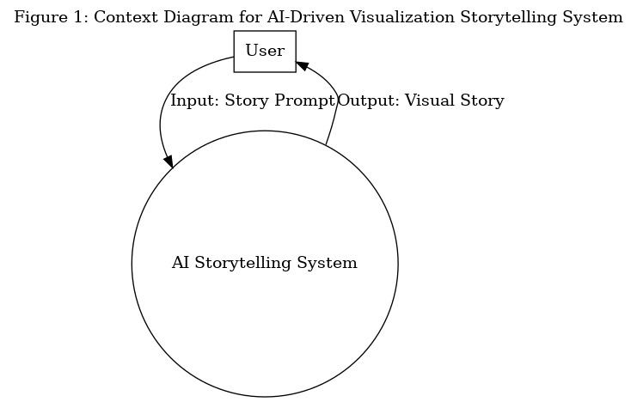

Figure 1: Context Diagram for AI-Driven Visualization Storytelling System

**Level 1 DFD**

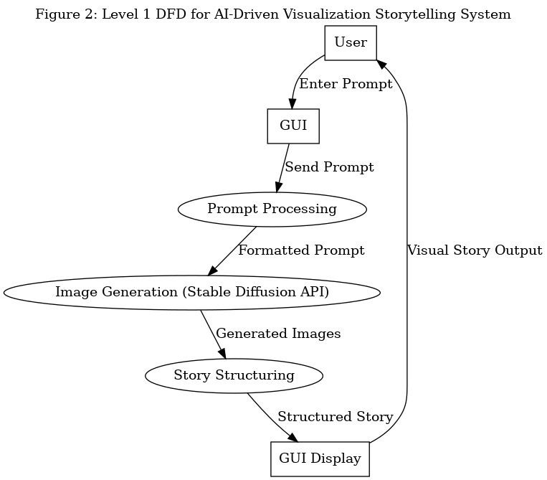

Figure 2:Level 1 DFD for AI-Driven Visualization Storytelling System

#### **Description**:

## **Level 0: Context Diagram** Imagine CONTRA as a creative genie—you whisper a topic, and it conjures a multimedia masterpiece. Figure 1 maps this high-level interaction:

## **The Cast:**

## Storyteller (User): You, the idea provider.

## AI Maestro (Central Process): CONTRA’s brain orchestrating the show.

## **Enter the topic:**

## Input: Your topic/prompt (*“quantum physics”*).

## Output: A polished package blending story, art, and data—like Netflix for learning.

## This big-picture view hides CONTRA’s behind-the-scenes wizardry, focusing on its core promise: *simple input → rich output*.

## **Level 1: Behind the Curtain (Process Breakdown)** Figure 2 reveals CONTRA’s creative assembly line:

## **Stage 1: Idea Intake**

## **Actor**: *You* (via the interface).

## **Action**: Drop a topic (e.g., *“Renaissance art”*) → **GUI** catches it like a digital net.

## **Stage 2: Prompt Polish**

## **Idea Refinery**: Raw thoughts get sculpted into AI-friendly prompts (*“Renaissance art” → “Generate a visual story about Renaissance art highlighting Da Vinci and chiaroscuro techniques”*).

## **Stage 3: Art Studio**

## **Stable Diffusion Painter**: Takes polished prompts → paints images (*think: AI Botticelli*).

## **Stage 4: Story Weaving**

## **Narrative Tailor**: Stitches images + facts into a flow: *“Start with origins → key artists → techniques → legacy.”*

## **Finale: Showtime**

## **GUI Theater**: Serves up the full experience—scrollable story, clickable art gallery, interactive timelines.

**Data Choreography**:

## **User’s Creative Brief** → GUI → **Refined Prompt** → AI Artist → **Masterpiece Assets** → Story Weaver → **Final Cut** → Your Screen.

**Conclusion**

The CONTRA project redefines the intersection of artificial intelligence, data visualization, and creative storytelling by addressing the critical challenge of fragmented information consumption in the digital age. By seamlessly integrating authoritative data sources (Wikipedia, DBpedia, GNews), advanced AI models (LLaMA 3.3-70B for narratives, Stable Diffusion 3.5 for imagery), and interactive visualization tools (Plotly, D3.js), the platform transcends traditional single-format content delivery. CONTRA’s architecture—built on Python’s Flask framework with modular API gateways, intelligent caching, and adaptive frontend design—demonstrates how automation can coexist with factual rigor, ensuring outputs are both engaging and trustworthy.

This innovation bridges the gap between education and artistry, enabling users to explore topics through personalized lenses while maintaining scholarly accuracy. By prioritizing accessibility, CONTRA democratizes cutting-edge AI tools for non-technical audiences, empowering educators, curators, and learners to transform static data into immersive, multidimensional experiences. Future enhancements could expand its cultural adaptability, integrate real-time collaborative features, or leverage emerging AI advancements for deeper interactivity. Ultimately, CONTRA stands as a testament to how technology can harmonize creativity and knowledge, fostering curiosity while equipping users to navigate complex subjects with clarity and wonder.

## **References**

1. R. Rombach, A. Blattmann, D. Lorenz, P. Esser, and B. Ommer, “High-Resolution Image Synthesis with Latent Diffusion Models,” in *Proc. IEEE/CVF Conf. Computer Vision and Pattern Recognition (CVPR)*, 2022. [Online]. Available: <https://arxiv.org/abs/2112.10752>  
   *(For Stable Diffusion model)*
2. Hugging Face, “🤗 Diffusers: State-of-the-art diffusion models in PyTorch,” [Online]. Available: <https://github.com/huggingface/diffusers>  
   *(Used via API for image generation)*
3. Python Software Foundation, “Python 3.x Documentation,” [Online]. Available: <https://docs.python.org/3/>
4. F. Pedregosa et al., “Scikit-learn: Machine Learning in Python,” *J. Mach. Learn. Res.*, vol. 12, pp. 2825–2830, 2011.  
   *(Used for TF-IDF vectorization and MLP if included in model experimentation)*
5. Matplotlib Developers, “Matplotlib: Visualization with Python,” [Online]. Available: <https://matplotlib.org/>  
   *(Used for visualizations like DFD/ERD)*
6. [7] Graphviz Developers, “Graphviz - Graph Visualization Software,” [Online]. Available: <https://graphviz.org/>  
   *(Used to generate system architecture diagrams)*
7. [8] M. Abadi et al., “TensorFlow: Large-Scale Machine Learning on Heterogeneous Systems,” 2015. [Online]. Available: <https://www.tensorflow.org/>  
   *(If TensorFlow/MLP is used for classification tasks)*

.